**Spaghetti Squash and Farro Casserole**  
Recipe by Back Forty Chef Michael Laarhoven

Serves 6

**[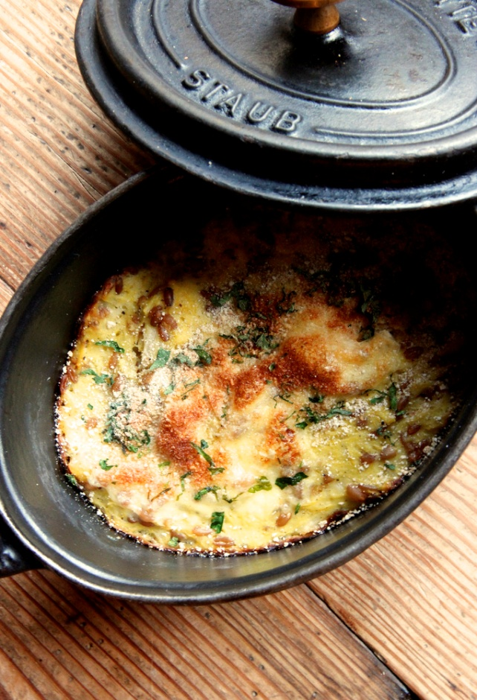](http://nyc.cleanplates.com/healthier-recipes/comfort-food-makeover-casserole-by-back-forty-west/attachment/spaghetti-squash-casserole/)**2 spaghetti squash, halved and seeded  
2 c. root vegetables (e.g. turnip and rutabaga), cut into large dice  
½ c. olive oil  
1 large onion, chopped  
1 c. dry white wine  
2 c. farro  
8 c. vegetable stock  
3 cipollini onions, thinly sliced  
6 eggs  
½ c. flour (Clean Plates recommends using unbleached white flour, or trying spelt flour)  
¼ c. organic heavy cream  
1 c. semi-hard sheep’s milk cheese (Back Forty West uses Coomersdale from Bonnit View farms), shredded  
2 c. fresh bread crumbs  
1 tsp. tarragon  
1 tsp. parsley  
sea salt  
pepper

Preheat oven to 350° F. Coat squash and root vegetables with ¼ c. olive oil and season with salt and pepper. Roast squash and root vegetables for approximately 45 minutes.

While squash and root vegetables are roasting, sauté the large onion in remaining ¼ c. olive oil over medium flame until soft and translucent. Stir in farro and cook for 1 minute.

Add white wine and reduce for five minutes, then gradually start adding stock, stirring often, until farro is firm and has absorbed all the liquid. When farro is done, allow to cool.

When squash is cooked, scoop into a large bowl and allow to cool. Add farro to squash pureé then stir in the cipollini onions, flour, and cream and season accordingly.

Place contents in a cast-iron casserole pot and bake covered for 20 minutes.

Top casserole with cheese, bread crumbs, and herbs, bake for five more minutes, then serve.